8th grade ELA Syllabus
Mrs. Henry
2016-2017
Email: henrys@weldoncityschools.k12.nc.us

Welcome
Welcome to 8th grade ELA. I’m Mrs. Henry and I’ll be facilitating your learning. This course will take us on a journey through different avenues in ELA. This year, we will be reading and writing in many genres for a variety of purposes. Our work includes studies of fiction, non-fiction, poetry and literary response as we continue to prepare for high school English. Grammar, vocabulary and spelling will be integrated into our work throughout the year. This is going to be a great year!

Course theme
This year the 8th grade has chosen to go with the theme of Freedom Fighters. We look forward to learning about and honoring those who have given us the opportunities we are afforded today. One of the best ways we can honor their legacy is by valuing our education and work toward leaving a lasting legacy of our own.

“Memories of our lives, of our works and our deeds will continue in others”.
-Rosa Parks

Class Expectations
- Be Respectful
  - Respect yourself, others & our school
  - Ask permission to speak & get up from your seat: 1st raise your hand silently. 2nd wait to be acknowledged by me.
  - Positive language at ALL times
- Be Responsible
  - Complete assignments
  - Take care of materials & classroom
  - Clean up behind yourself
  - Come to class every day on time
- Be Ready to Learn
  - Bring notebook, needed supplies, and homework EVERYDAY
  - Be in your seat, working on your Do Now
  - Listen, participate, and give 100% all the time with everything
- Be Safe
  - Walk in the hallways
  - Push in your chairs in the cafeteria
  - Do not hit or shove another student

Attendance & Make-up Work
Every student is expected to be in class on time everyday. I will lock the door once the tardy bell goes. If the student does not have a pass from the previous teacher, then the student will be written up for cutting class. After 5 tardies student will receive further discipline.

If a student is absent, it is his/her responsibility to schedule a time to make up any missed assignments.

20 or more unexcused absences will result in an automatic failure of the course.

Classwork & Homework
All work that is handed in for grading must be complete or it will receive an automatic 0.

If an assignment is not handed in on time, 10 points will be deducted for every day that the assignment is late. After 3 days the assignment will be an automatic 0.

Test & Quizzes
A unit test will be given after every unit of study. Students will be given ample time to study and ask questions. There will be a review day before each major test.

If a student is absent on the day of a test it is his/her responsibility to schedule a time to make up the test.

Students may submit test and quiz correction once. They will receive half credit for questions they redo and get correct.

Projects
A quarterly project will be assigned. Students will have ample time to complete the assignment. Being that projects are assigned well in advance and take a great amount of time to grade, students must turn them in on time. I cannot accept projects turned in more than 3 days late and 15 points will be deducted for everyday the project is late. After 3 days the project will be an automatic 0.

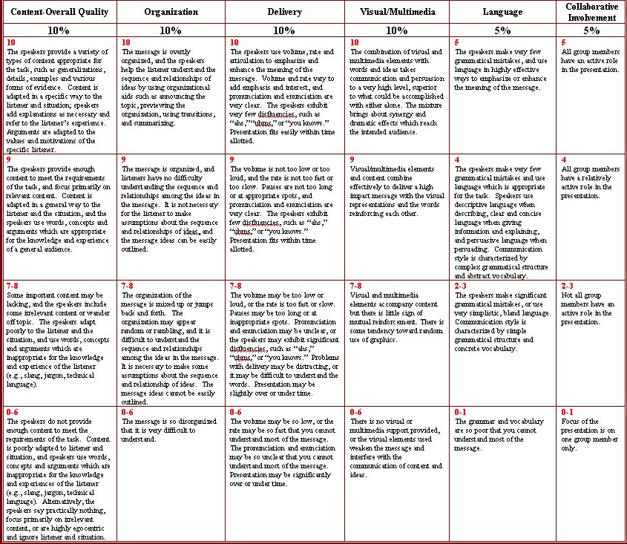
Sample Rubric:

Grading

Letter grades will be assigned based on Weldon City Schools’ District Grading Policy. The corresponding scale follows:

Letter Grade | Numerical Range
A | 90-100
B | 80-89
C | 70-79
D | 60-69 (no credit)
F | <59 (no credit)

Progress reports will be sent out every 3 weeks. If you do not receive something from your child, please contact the 8th grade team.

Method of Grading

Category | % of Grade
Projects | 30%
Classwork/ Homework | 30%
Assessments | 35%
Intervention | 5%

Plagiarism:

Plagiarism and cheating have no place in a community of scholars. Have the confidence in yourself to give your original best!

Communication:

Together, we will make this year a very successful and rewarding year for you. I will be in touch periodically with parents. Parents can feel free to contact me. I can respond quicker via email. I look forward to teaching you and making a difference in your life.

School Phone: 252-536-2571 ext. 284
Email: henrys@weldoncityschools.k12.nc.us
Text: @henrys12 to 81010

PLEASE RETURN THIS SECTION TO MRS. Henry
_________________________________________cut along this line__________________________________________
Please detach and return signed slip below by Friday September 2th, 2016
***This is worth a 100 homework grade***

I, _________________________________________have read and understand the 8th grade ELA syllabus. I agree to follow these classroom procedures and expectations in order to have a successful and meaningful school year.

Student Signature: _______________________________________________ Date: _____________________

Parent Signature: ________________________________________________ Date: ______________________

Please note that policies outlined in this syllabus are subject to change.

